**DAILY ONLINE ACTIVITIES SUMMARY**

|  |  |  |  |  |  |  |  |
| --- | --- | --- | --- | --- | --- | --- | --- |
| **Date:** | 10/06/2020 | | | | **Name:** | CHETHAN CK | |
| **Sem & Sec** | 4th SEM ‘A’ SEC | | | | **USN:** | 4AL18CS017 | |
| **Online Test Summary** | | | | | | | |
| **Subject** | | Object Oriented Concepts(18CS45) | | | | | |
| **Max. Marks** | | 30 | | **Score** | | 16 | |
| **Certification Course Summary** | | | | | | | |
| **Course** | Facial recognition using python | | | | | | |
| **Certificate Provider** | | | Udemy | **Duration** | | | 3 Hours |
| **Coding Challenges** | | | | | | | |
| **Problem Statement:** 1. Write a java program to count all the triplets such that sum of two elements equals the third element.  2. Write a C Program to print the sum of boundary elements of a matrix. | | | | | | | |
| **Status:** Completed | | | | | | | |
| **Uploaded the report in Github** | | | | YES | | | |
| **If yes Repository name** | | | | https://github.com/alvas-education-foundation/chethan_c_k | | | |
| **Uploaded the report in slack** | | | | YES | | | |

**Online Test Details:**

The online test was from module 3 and 4. There were 15 questions and the duration was 30 minutes. The questions were optimal and were easy. The score that I got in the test is 16/30.

**Snapshot:**

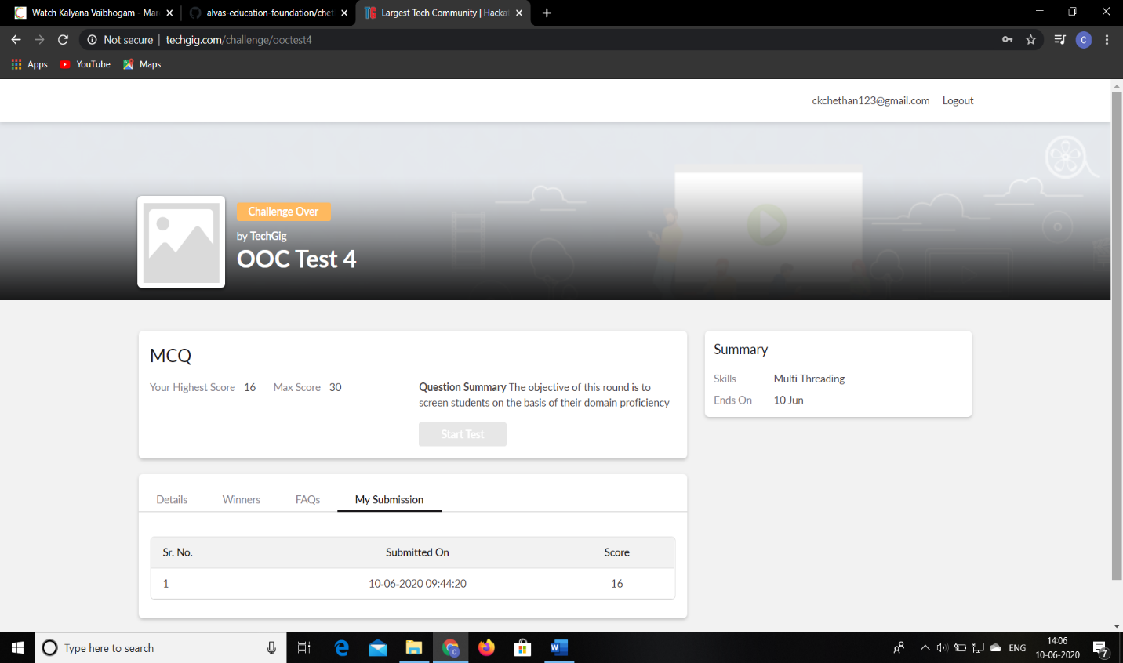

**Certification Course Details:**

**Name of the course**: Facial recognition using python

**Certificate Provider**: Udemy

Today I had learned about video facial expression detection.

**Snapshot:**

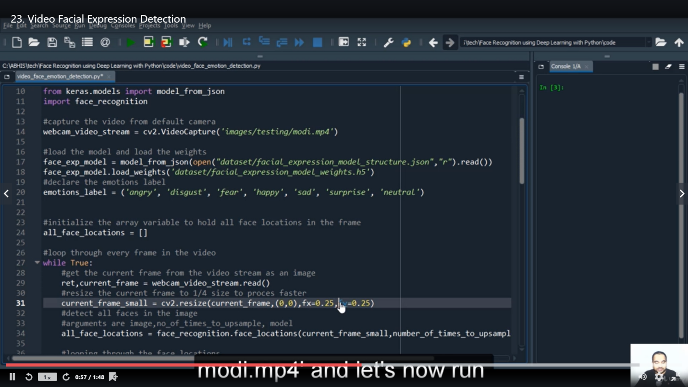

**Online Coding Details:**

Problem 1: (using Java language) To count all the triplets such that sum of two elements equals the third element.

**Snapshot:**

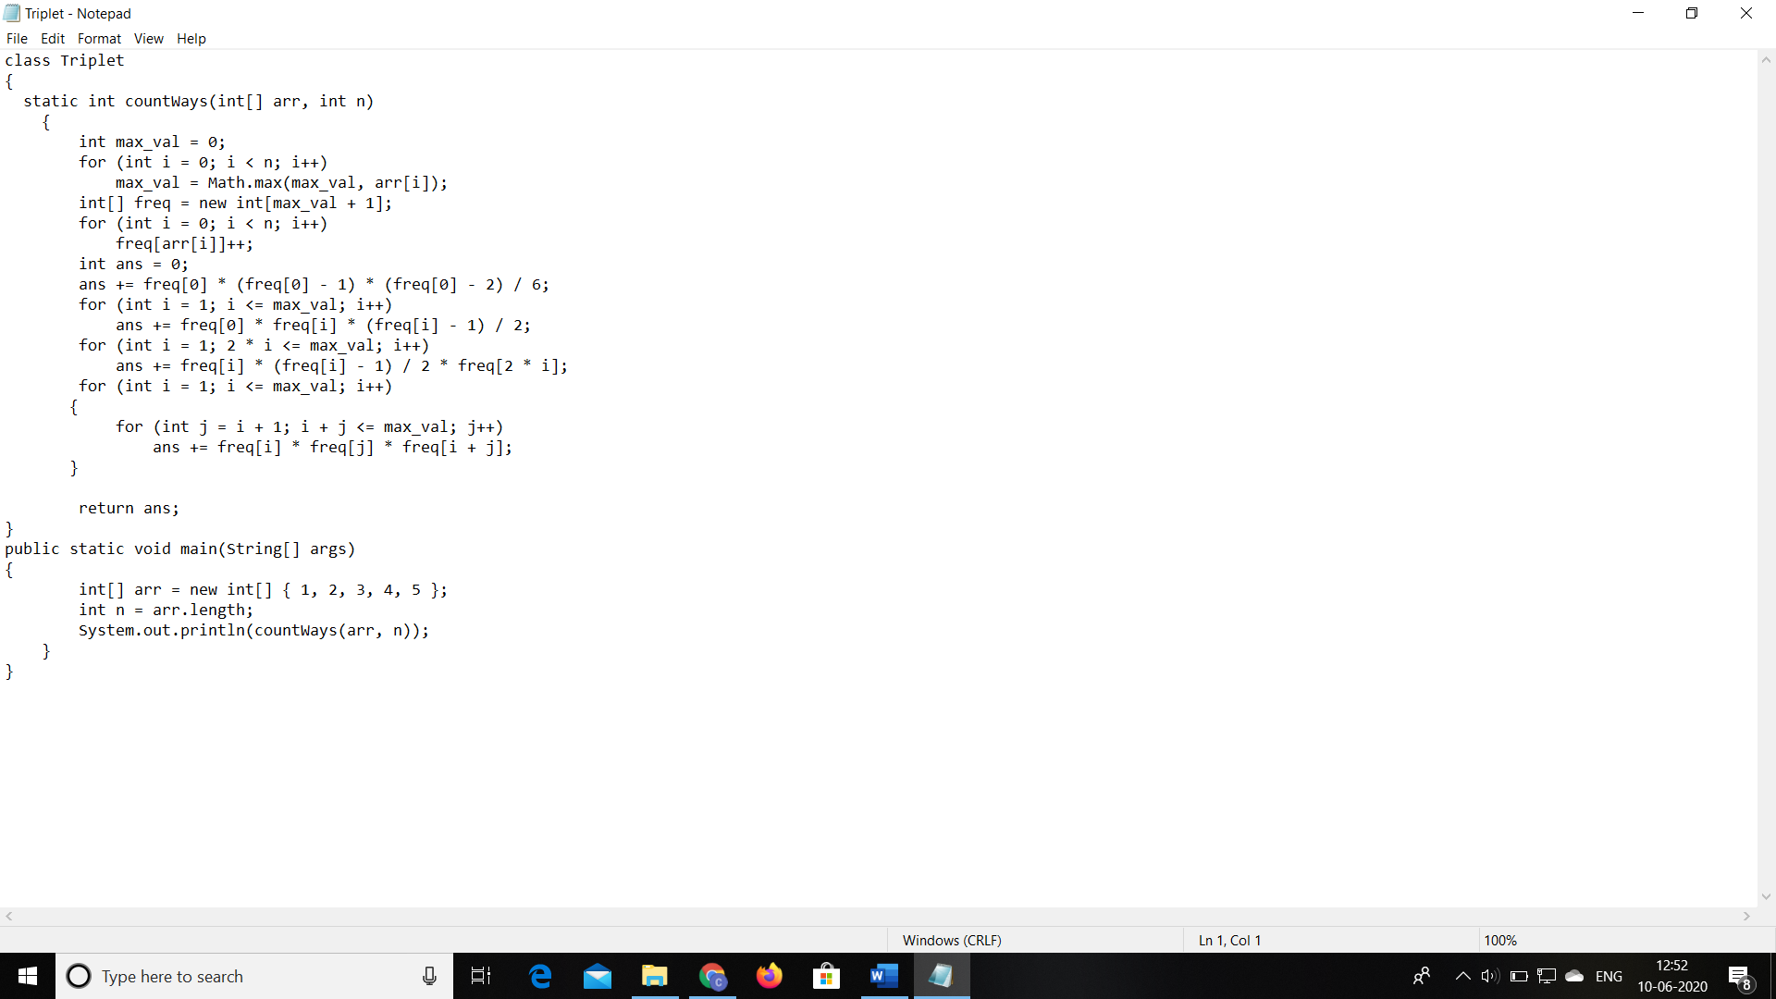

Problem 2:(using C language) To print the sum of boundary elements of a matrix.

**Snapshot:**

